**Department of Computer Science**

**Forman Christian College University**

**COMP360: Introduction to AI**

**Spring 2024**

**Lab 3**



|  |
| --- |
| **Total**  **(20 Marks)** |
|  |

**UCS: Uniform Cost Search**

**Lab Instructions:**

* Get your attendance marked before leaving the classroom.
* This is an individual Lab assignment. Each student must submit their own work.
* IMPORTANT: Run the lab#_name_roll#.py file and make sure it runs without any errors.
* Then populate the below mentioned files with your implementation.
* After you’re done with your implementation, change the python file “lab#_name_roll.py” and replace your “lab number”, “name” and “roll_no”.
* Finally upload them on tmoodle.

**Task 1:**

Using UCS Find the path to reach from **S** to **G** search.

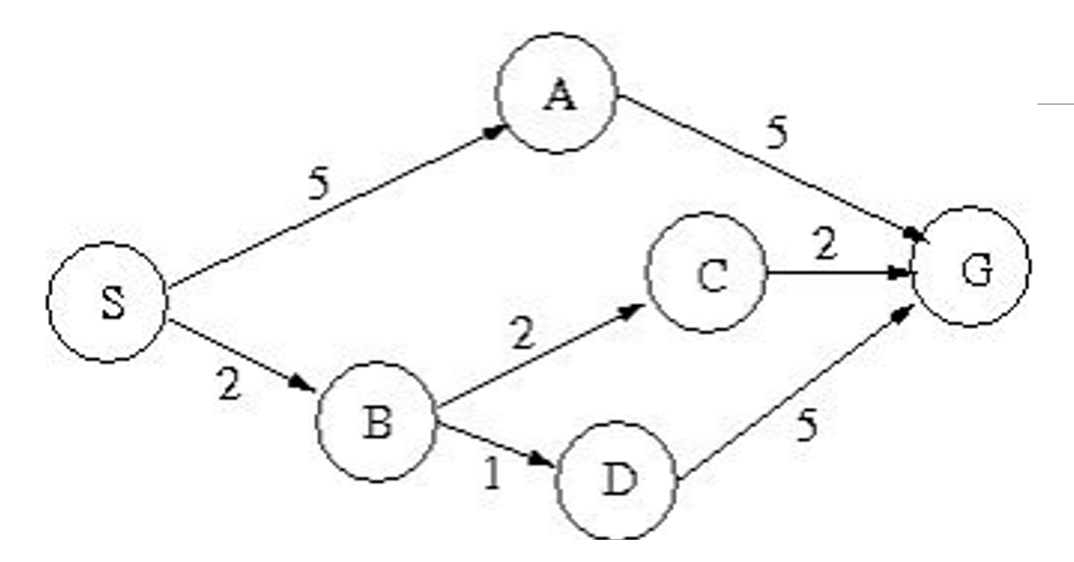

* You are provided with three files that are “graph.py”, “custom_queue.py” and “lab#_name_roll#.py”.
* Read the given code in the files.
* Fill in the function in the file “lab#_name_roll#.py”